**Oxidation Numbers**

* The **oxidation number** often referred to as **oxidation state**, describes the degree of oxidation (loss of electrons) of an atom in a chemical compound.
* The oxidation number shows the total number of electrons which have been removed from an element (a positive oxidation number) or added to an element (a negative oxidation number) to get to its present state.
* The oxidation number is a **hypothetical charge** that an atom would have if all bonds to atoms of different elements were 100% ionic, with no covalent component. This is never exactly true for real bonds.

**Rules for Determining Oxidation Numbers:**

To determine the oxidation number of an element the following “rules” are applied.

* The oxidation state of an uncombined element is zero. That is because it has not been oxidised or reduced yet. This applies whatever the structure of the element - whether it is, for example, Xe or Cl2 or S8, or whether it has a giant structure like carbon or silicon.
* The sum of the oxidation states of all the atoms or ions in a neutral compound is zero. e.g. NaOH, H2SO4, MgCO3 all have an overall oxidation number of zero.
* The oxidation state of a monatomic ion is equal to the charge of the ion e.g. Fe2+ is +2, Br- is -1
* The sum of the oxidation states of all the atoms in a polyatomic ion is equal to its charge. e.g NH4+ has an overall oxidation number of +1, whilst SO42- is -2
* The more electronegative element in a substance is given a negative oxidation state. The less electronegative one is given a positive oxidation state. Remember that fluorine is the most electronegative element with oxygen second.
* Some elements almost always have the same oxidation states in their compounds, this is shown in the table below:

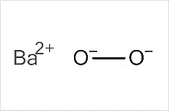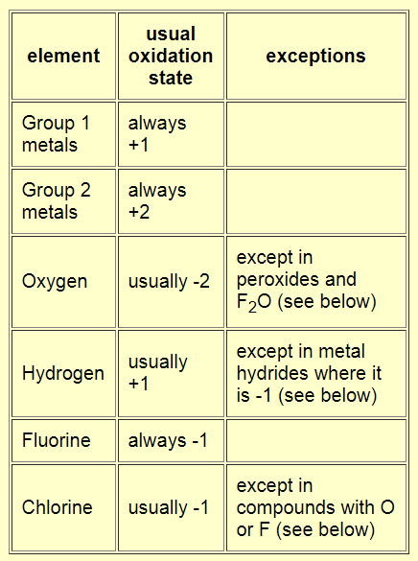



**Peroxides** are compounds containing the group, –O2–.

For example,

* hydrogen peroxide, H2O2,  H–O–O–H,
* Barium peroxide, BaO2

**Metal Hydrides** include compounds like sodium hydride, NaH. In this, the hydrogen is present as a hydride ion, H-.

For more detail, <https://www.chemguide.co.uk/inorganic/redox/oxidnstates.html>



**Valency Vs Oxidation Number**

These two concepts are similar and often confused.

**Valency** is the number of electrons that an atom needs to loose, gain or share in order to become stable. It is used for elements and can be determined by the electron configuration of the atom.

**The oxidation number** is the charge of the central atom if all bonds were considered ionic (i.e. bonding electrons “owned” by the more electronegative atom). It is used for compounds, and effected by the compounds formula and structure.

For Example:

The valency of carbon is always 4, however it can have many different oxidation numbers depending on the compound.



For compounds with many elements, calculus can be used to determine the unknown elements oxidation number.

For example, to determine the oxidation number of sulfur in H2SO4

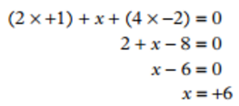

Therefore, S = +6

**Using Oxidation Numbers**

There are many uses of oxidation numbers including:

1. **Naming compounds** with transition metals.

For example, Fe2O3 is iron (III) oxide as iron has an oxidation state of 3

1. **Identification of redox reactions**

* an increase in oxidation number indicates oxidation (loss of electrons)
* a decrease in oxidation number indicates reduction (gain of electrons)
* if there is no change in oxidation number, no oxidation or reduction has occurred.

For example, in the burning of methane

The carbon in CH4 has increased in oxidation number from -4 to +4 therefore the methane is oxidised

The oxygen in O2 has decreased in oxidation number from 0 to -2 and therefore the O2 is reduced

1. **Identification of conjugate redox pairs**

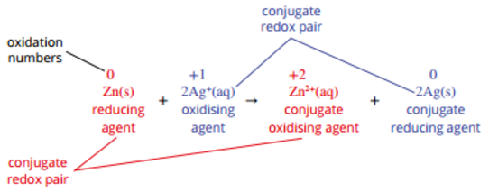Conjugate redox pairs refer to the electron donor and the corresponding electron accepter form. Conjugate pairs can be identified by a change in an oxidation number. In a redox reaction, there are always two conjugate pairs.

In the above reaction the two conjugate pairs are Zn(s) / Zn2+(aq) and Ag+(aq) / Ag(s)